Official league roster - Basketball
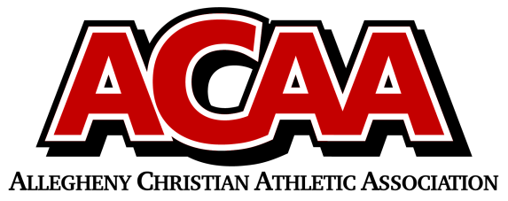

School Name: Great Commission School
Team Colors: Royal Blue & White
Overall Wins ___ Losses ____ Ties ___
ACAA Wins ___ Losses ____ Ties ___ OPPONENT: __________________________
Date: _________
Number | Name | Year | Position | Height | Homeschool
10 | Michelle McConnell | 11 |  | 5’5
21 | Kayelynn Summers | 11 |  | 5’
33 | Rachel Turiano | 11 |  | 5’9
15 | Sophia Fleck | 10 |  | 5’6
3 | Bayla Miller | 10 |  | 5’8 | YES
11 | Alexa Hall | 9 |  | 5’1
2 | Allison Hall | 8 |  | 5’ | YES
0 | Ava Bordack | 7 |  | 5’3

Head Coach: kay bordack
Asst. coach: megan grissinger
Stats: Peyton hicks
AD: julie lohsl

Official ACAA League Team Roster. to be submitted to the scorer’s table before each game.

